Nifedipine, Calcium Channel Blocker, as Tocolytic for Inhibting Preterm Delivery: A Systematic Literature Review of Randomized Controlled Trials

Joue Abraham Trixie¹, Abigail Serepina Siagian², Mathilda Abigail Irianti³

1. Universitas Kristen Indonesia – (+62) 81574924922, joueabraham@gmail.com
2. Universitas Kristen Indonesia – (+62) 81314752976, serepinabigail@gmail.com
3. Universitas Kristen Indonesia –(+62) 81240314576, abigaelmarpaung@gmail.com

- Introduction

Premature is known as the birth of an infant alive before 37 weeks during pregnancy.^{1,2} Towards the birth of subcategories of premature birth, ie, extremely preterm (<28 weeks), very preterm (28 to <32weeks), and moderate to late preterm (32 to <37 weeks). Globally, the premature births are number 1 cause of death in children under 5 years. 15 million babies are born prematurely as estimates. Nearly 1 million children die every year because of the premature as the complication. Many also survive, but live with disabilities.1 Disability such as respiratory disorders, eating disorders, cerebral palsy, growth disordes, visual disorders, and hearing loss.^{1,2,3} By 2015, 1 in 10 children in America, was born prematurely.² Indonesia is ranked 5th out of 10 countries with the highest rates of preterm birth.¹ The government needs to improve antenatal care services to address this issue.⁴

The therapy that used to deal with early uterine contractions is by giving tocolytics. Tocolytic can endure pregnancy, so there is enough time for the lung maturation for the fetus.⁵ Otherwise, there is sufficient time to obtain corticosteroids, in order to accelerate lung maturation in the fetus.⁶ Tocolytic examples are mimetic beta groups, oxytocin receptor inhibitors, and calcium channel inhibitors. Each tocolytic has its own side effects and each pharmacodynamics.

The ideal tocoloytic should be effective, easy to use, no significant adverse effects on mothers and fetuses, and adequate for corticosteroids on antenatal services to reach the effects.⁸ Beta mimetics are the most commonly used tocolytics. Reliable for pregnancy up to 7 days, no side effects on perinatal death.^{9,10} However, side effects can caused the mother, tachycardia and hypotension. Furthermore, about betamymetics is related to 25 cases of maternal death due to pulmonary edema.¹¹

The uterus is a miogenic organ and this organ contracts spontaneously following the electrical wave activity resulting from membrane depolarization, ie the increase in intracellular calcium levels.³ Calcium channel blocker (CCB) blockers will prevent the calcium from outer cell get into the cell.12 Thus, a channel inhibitor commonly known as a hypertension drug that may prevent premature birth.^{7,12,13,14} The most common calcium channel blocker is the dyedropropyridine group, nifedipi. The first reported in 1980 nidedipine can act as effective tocolytics.¹⁵ Only at that time the tocolytic still cannot replace the betamymetics that used in clinical practice.¹

Study Purpose

1. Find new ways to prevent preterm birth
2. Discuss whether calcium channel blockers can prevent preterm birth better than the existing tocolytics
3. Assess the efficacy and safety of calcium channel blockers, both in pregnant women and infants.
- Research Methodology

  - Search Strategies

A comprehensive literature search was conducted in October 2017 using the database such as PubMed Central, PubMed Health, The Cochrane Library, ScienceDirect, MedlinePlus, The Lancet, The Journal of Maternal-Fetal & Neonatal Medicine, dan Sage Journal. The combinations of terms used for the search included “Calcium Channel Blocker AND Tocolytic”, “Calcium Channel Blocker AND Pregnancy”, and “Calcium Channel Blocker AND Preterm delivery.” Where applicable and available, appropriate advance search techniques were applied to narrow the search.

2.2 Selection of Trials

Inclusion Criteria:

• Randomized, controlled clinical trials
• Pregnant Woman at risk of preterm delivery within the range of 20 weeks to 36 weeks
• Use calcium channel blocker, nifedipine as tocolytic
The study was conducted within the period 2011 - 2017

2.3.Data Extraction

The following data was extracted from the studies:

- Prolongation of Preganancy
- Maternal Side Effect
- Neonatal Side Effect
- Study Design: Population characteristics (Age, Gestational age, Cervical dilatation, Diagnosis of preterm labor), Intervention, Comparassion, and Outcome measurement.

  - Quality Assessment

The quality of controlled clinical trials was examined based on the method of Jadad, a method for assessing the quality of controlled clinical trials. Basic Jadad Score is assessed based on the answer to the following 5 questions. The maximum score is 5. All of the criteria were scored with either yes or no. A “yes” was given one point, whereareas a “no” was given a score of 0.¹⁶

Two reviewers (JAT, ASS) independently analyzed the included studies based on the quality assessment criteria.

Question | Yes | No
1. Was the study described as random? | 1 | 0
2. Was the randomization scheme described and appropriate? | 1 | 0
3. Was the study described as double-blind? | 1 | 0
4. Was the method of double blinding appropriate? (Were both the patient and the assessor appropriately blinded?) | 1 | 0
5. Was there a description of dropouts and withdrawals? | 1 | 0
Quality Assesment Based on Jadad Score

Range of Score | Quality
0 – 2 | Low
3 - 5 | High

- Result

3.1. Research Findings and Study Selection

The search team were applied to all of the 8 search engine and database mention earlier. Titles and abstracts were screened and relevant titles were selected. After removal of duplicates, a total of studies were obtained from the database search. Initial screening of abstracts against eligibility criteria excluded 5 studies. A further 10 trials were excluded after reading full text articles as they did not have a viable study design based on preset inclusion and exclusion criteria (Figure 1).

Therefore, this review includes 5 randomised trials testing the effects of CCB for tocolysis in preterm labour. A total of 621 pregnant women participated in the 5 trials. There were no placebo controlled trials identified. There were no trials in which a CCB was compared with no tocolytic agent. The 5 included trials all compared results of tocolysis by a CCB, nifedipine with an alternative tocolytic.

The five clinical trials selected in this systematic literature review were conducted by Rezk M, et al. (2015)¹⁸, Nikbakht, et al. (2014)¹⁹, Vliet, et al. (2016)²⁰, Bankatlal, et al. (2011)²¹, and Klauser, et al (2013)²².

Initial Search Results from PubMed Central
(n = 135 )

Initial Search Results from PubMed Health
(n = 29 )
Initial Search Results from The Cochrane Library
(n = 1)
Initial Search Results from Science Direct
(n = 4)
Initial Search Results from The Lancet
(n = 4)
Initial Search Results from The Journal of Maternal Fetal & Neonatal Medicine
(n = 1)

Relevant Titles (n = 4)
Relevant Titles (n= 12)
Relevant Titles (n = 2)
Relevant Titles (n = 1)
Relevant Titles (n = 1)
Relevant Titles (n = 2)

Results of Database Searching
(n = 22)

Studies After Duplicates Removed
(n = 20)

Studies Screened (n = 20)
Studies Excluded (n = 5)

Full-Text articles assessed for Eligibility (n = 15 )
Full Text article excluded (n = 10)

Randomized Controlled Trials include in the Systematic Review (n = 5)

Figure 1: Flow Chart of Search

3.2. Quality of the Included Studies

From the result of this quality assessment, all 5 studies were defined as high quality studies, and can to be seen in the table below:

Table 1: Results of Quality assessment for the five studies
Criteria | Rezk M, et al. | Nikbakth, et al. | Vliet, et al. | Bankatlal, et al. | Klauser, et al.
1. Was the study described as random? | Yes | Yes | Yes | Yes | Yes
2. Was the randomization scheme described and appropriate? | Yes | Yes | Yes | Yes | Yes
3. Was the study described as double-blind? | Yes | Yes | No | Yes | No
4. Was the method of double blinding appropriate? (Were both the patient and the assessor appropriately blinded?) | Yes | Yes | Yes | Yes | Yes
5. Was there a description of dropouts and withdrawals? | No | No | No | No | No
Score | 4/5 | 4/5 | 3/5 | 4/5 | 3/5

3.3. Participants

The characteristics of the participants included in these trials were clinically similar. The minimum gestational age at inclusion ranged from 20 to 28 weeks, and the maximum from 32 to 37 weeks. The mean gestational age at entry, when described, was between 28 and 34 weeks' gestation. Preterm labor was reasonably consistently defined across the trials, most excluding those women with a cervical dilatation of greater than 4 cm. One trials included twin pregnancy

The standard indication for tocolysis were reported as inclusion criteria in the majority of included trials ; at least 2 times of contraction every 10 minutes or 4 times above 30 minutes or 3 times every 30 minutes or 4 times every 20 minutes. Cervical dilatation also includes preterm labor with an average of 0 to 4 for primers and 1 - 4 for multi. In twin babies dilatation can reach 6 cm. Preterm can also determinate via ultrasound.

3.4. Tocolysis Regimens

Five trials compared oral nifedipine with other tocolytic agents. The other tocolytic was Indomethacin, Magnesium sufat, Ritodrine, Atosiban, and Nicorandil. Initial tocolytic therapy with nifedipine was administered orally. Initially, the initiation of nifedipine dose varied, from 10 mg to 30 mg in the first hour. Administration followed by maintenance dose. The maintenance dose is administered from 10 mg – 30 mg every 6 - 8 hours for the next 48 hours. In one clinical trial, nifedipine was administered until the age of gestation reached 37 weeks. One other clinical trial is given until the contractions stop.

3.5. Study Design and Characteristics

Table 2 shows a summary of all the studies included in the inclusion criteria. All of the studies are followed by the same study and can be compared reliably. All study were double-blinded (except for Vliet, et al and Klauser, et al) and adequate randomized the subject. In all studies, only healthy pregnant women were selected.

Table 2: The Summary of Randomized Clinical Trials of The Five Studies
Study | Population | Intervention | Comparassion | Outcome Measure
Rezk M, et al¹⁸ | Age: 18 - 27 Years Gestational Age: 28 - 33 weeks  Cervical Dilation = 0 - 3 cm  Diagnosis of preterm labor: 2 times uterine contractions with in a 10 minutes period in the 60 minutes | 20 mg followed with 10 mg every 8 hours during 48 hours | Nicorandil, 20 mg given, followed with 10 mg every 8 hours during 48 hours | Nifedipine and Nicorandil are both successful in extending the gestation period for 48 hours. However, nicorandil tends to cause maternal and fetal tachycardia compared to nifedipine
Nikbakth, et al¹⁹ | Age: 18 - 40 years  Gestational Age: - / + 40 weeks  Cervical dilatation: 0 - 4 cm  Diagnosis of preterm labor: 4 times uterine contractions more over, each lasting at least 30 seconds | 10 mg, repeated every 20 minutes (for 1 hour maximum dose is 30 mg). Following a maintenance dose of 10 mg every 6 hours | Magnesium sulfate, given 10g (I.V) and 5g (I.M) every 4 hours. | Nifedipine and Magnesium sulfate are both successful in extending the pregnancy to over 7 days. Side effects given are not much different
Vliet, et al²⁰ | Age: 18 years  Gestational Age: 25 - 34 weeks  Cervical dilatation: 1 - 3 cm  Diagnosis of preterm labor: 3 times uterine contractions per 3 minutes | 20mg, followed by 20mg every 6 hours for 47 hours | Atosiban, given 20mg, followed by 20mg every 6 hours for 47 hours | Nifedipine and Atoiban are both successful in extending the gestation period for 48 hours. The resulting perinatal outcome is not much different.
Bankatlal, et al²¹ | Age: 22 years  Gestational Age: 33 weeks  Cervical dilatation: 1 - 3 cm  Diagnosis of preterm labor: 4 times uterine contractions in 20 minutes | 20mg is given every 8 hours to 37 weeks or until labor process occurs | Ritrodrine of 100 mg (2 ampoules of ritrodrine containing 50 mg) was added to 500 ml of ringers lactate. The infusion was started at the rate of 50 g / min and increased by 50 μg every 15 minutes until the uterus stopped contraction. The maximum dose is 350 μg/ min. | Nifedipine is more effective in prolonging pregnancy than Ritrodrine. The side effects are also less.
Klauser, et al²² | Age: 18 - 26.5 years  Gestational Age: 20 - 32 weeks  Cervical dilatation: 1 - 6 cm  Diagnosis of preterm labor: There is a contraction of the uterus for 5 minutes or less | Nifedipine with initial dose of 30mg, followed by maintainance dose 20-30mg every 4-6 hours until contraction stopped | Magnesium sulfate at a dose of 6mg (I.V) for 20 minutes, followed by maintaince dose of 4-6 mg every hour until contraction decreases <6 / hours before discontinuing the IV.  Indomethacin was given as a 100mg suppository which could be repeated one time, two hours after the initial dose if contractions continued. Followed by 50mg of oral indomethacin every 6 hours until contractions were extinguished for at least 1 – 2 hours | There was no significant difference between the three agents. Side effects of tocolytics and hypotension are more commonly caused by nifedipine.

3.6.1 Study Outcome: Prolongation of Pregnancy

The prolongation of pregnancy was primarily measured by the uterine contractions. The result show that the average of prolongation was 48 hours. The rest time is mean for pregnant women got kortikosteroid to maturity the neonates lung. Also nifedipine is more effective than the other tocolytic.

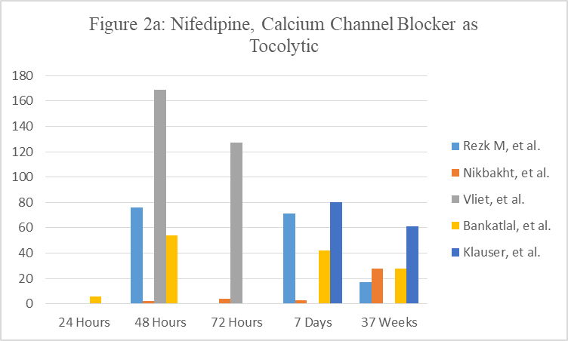

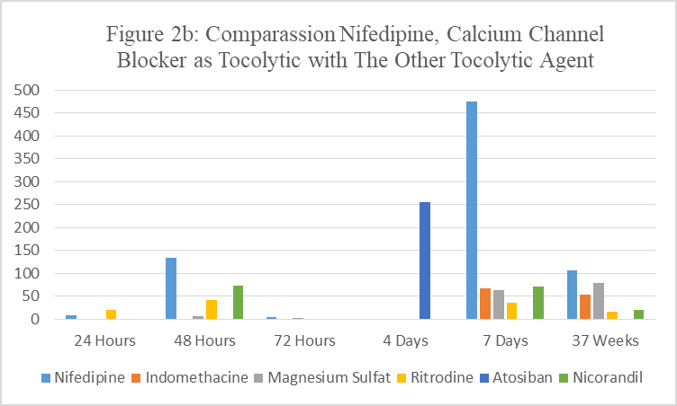

3.6.2 Study Outcome: Maternal Side Effect

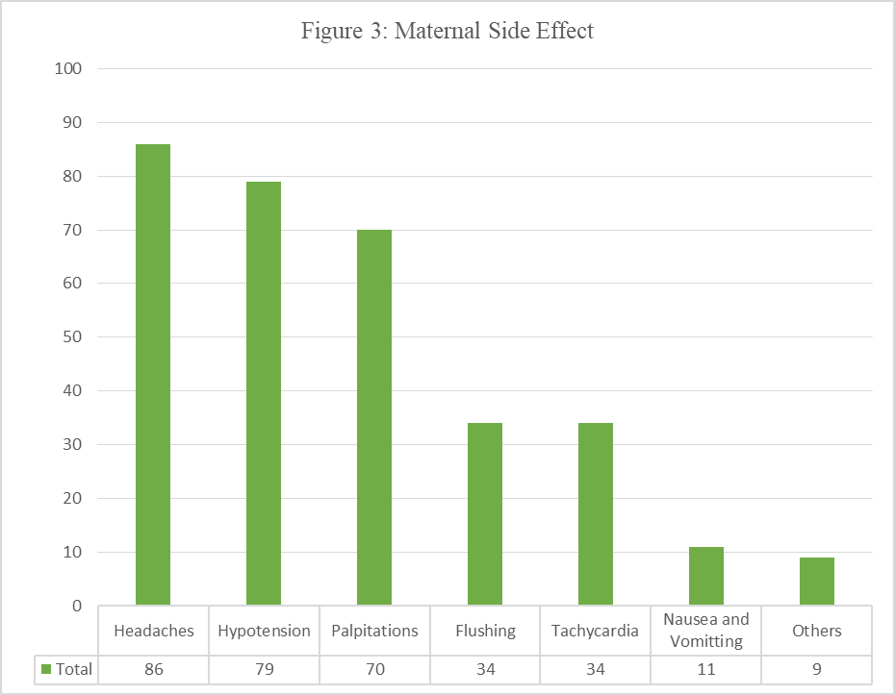
The most maternal side effect was headaches, hypotension, and palpitations. It could stop the treatment. Blood pressure was measured each tocolytic administration.

3.6.3 Study Outcome: Neonatal Side Effect

3.6.3.1 Perinatal Death

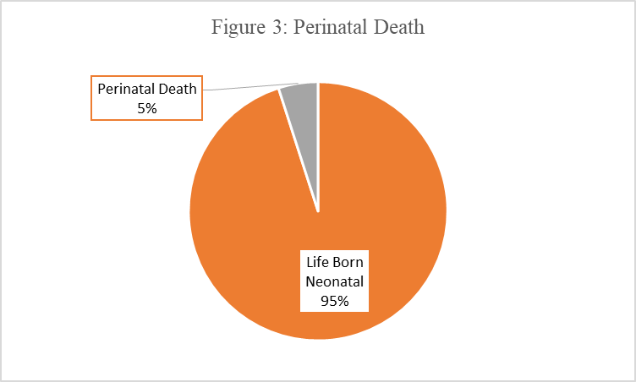

3.6.3.2 NICU Admission



Out of the 626 babies who were born, 31 of them were dying. The causes include Respiratory Distress Syndrome, septicemia, intraventricular hemorrhage, bronchopulmonary dysplasia, sepsis, and necrotizing enterocolitis. In some infants may also experience meningitis, pneumothorax, apnoe, and asphyxia. But, in small quantities. Not all clinical trials examine the baby's weight.

Overall, the baby deliver with a weight of 1.008 grams up to 3000 grams. Hospital days overall is 1 to 73 days. Depending on the condition of the baby when born. The length of treatment depends on the baby's weight, apgar score, the need for ventilation, and the presence or absence of respiratory distress syndrome.

- Discussion

  - Analysis of Results

This systematic literature review will examine the usage of nifedipine (dihydropyridine class) as tocolytic in Preterm delivery. The writers will divide the table of research based on three parameters which are prolonged pregnancy, the maternal side effect, neonatal outcome after use of nifedipine based on previous clinical trials.²⁵

Tocolytic is used to decrease the contraction of myometrium and being used in preterm delivery. Tocolytic administration is important in preterm labor to improve the neonate outcome. Tocolytic will delay the preterm delivery so the healthcare can administer the antenatal corticosteroid to enhance the fetal lungs maturity. The lungs maturation decreases the probability of having respiratory distress syndrome in neonates.²⁷

Myometrium contraction occurs because the increase of intracellular calcium (Ca2+). The voltage gated Ca2+ mediates the calcium into the cell causing cell depolarization and regulate the intracellular myometrium contraction.²⁸ Nifedipine is the type 2 calcium channel blocker which will inhibit the calcium flows by binding into the L type slow calcium channel influenced by the Ca2+-activated K+ channels, beta-adrenergic receptors (β-ARs) and sexual hormones.²⁵ The L-type calcium channels, which are widely expressed in cardiac and smooth muscles.²⁶ Inhibition in this calcium channel prohibits calcium enter the cell, so the cell will not be depolarized. This causes the intracellular relaxation of myometrium.

Figure 2a shows the effectiveness of Nifedipine to prolonged the pregnancy for 48 hours to 37 weeks. The prolongation of pregnancy for 48 hours is comparable between the study (68% in Elvira Fliel, 90% in Jaju Bankatlal, 76% in Rezk M, 76,9% in {Nama penelitinya} and 8 % in Nikbakht). Although nifedipine is effective in prolongation of pregnancy in 48 hours, the prolongation of pregnancy in 7 days shows a fewer number (51% in Elvira Fliel, 70% in Jaju Bankatlal, 71% in Rezk M, 56,9% in Chad K. Klauser) except for Nikbath’s research that shows more cases in nifedipine ability to prolong the pregnancy for 7 days (56%) than the 48 hours prolongation (8%). From all the literature reviewed, nifedipine is effective to be used in prolongation of pregnancy for preterm delivery.

Nifedipine causes several side effects in pregnant woman. The most common maternal side effect is hypotension (70% in M Rezk, 6.7% in Chad Cluster) followed by headache (70% in M Rezk and 20% in Juju Bankathal) and flushing. Nifedipine dilates the systemic and pulmonic blood vessels and decreases the arteries resistance. Besides, nifedipine also can decrease 20% of the systolic pressure, diastolic pressure, and mean arterial pressure.²⁹ Those contribute in occurring hypotension in pregnant woman who use the Nifedipine as tocolytic. The vasodilatation effect of Nifedipine causes headache and flushing in patient. It is also reported that high doses of nifedipine (150mg / day) may cause severe dyspnea.²⁶

However, maternal side-effects posed by nifedipine administration as tocolytic are few compared to other tocolytic agents.¹⁴

Of the 626 babies who were born, 31 of them were dying. The most common cause is respiratory distress syndrome. However, of all tocolytics that cause respiratory distress syndrome, the amount of respiratory distress syndrome induced by nifedipine is relatively less then other. Likewise with necrotizing enterocolitis, intraventricular hemorrhage, and neonatal jaundice.^{14,23}

The Neonate Intensive Care Unit is more than 30% (37% in M Rezk, 55% in Banda Janju, 52.5% in Elvira Villet). Neonatal Intensive Care Unit is an intensive unit specialize for premature newborn infant, have low birth weight (<2,5 kg), or have a medical condition that requires special care. In preterm delivery, Nifedipine works by delay the delivery but the infants are still premature newborn. These infants are admitted into NICU to receive further medical treatment so that they can improve their health performance. The low birth weight in neonate happens because the infants were born before 42 weeks. In the following research, they used nifedipine as tocolytic for 32-37 weeks gestational.

Based on the literature which are reviewed, The researches show that from 626 born infants, there are 31 cases of neonatal death (5%). The following causes of neonatal death are respiratory distress syndrome, septicemia, intraventricular haemorrhage, broncopulmonary dysplasia, and sepsis 5. There’re some risk factors that can lead to neonatal death such as maternal age, gestasional age, the maternal hemoglobin rate, etc 6 .Certain mechanism also can cause the neonatal death despite the use of nidepine like prolongation of pregnancy can improve respiratory neonatal outcome but it can lead to fetal death due to circulatory problem.

  - Limitations of Study

Of all the clinical trials used, no trials discusses what dose will cause neonatal side effects. Nor is any trials discussed the administration of nifedipine other than oral. There is also no recommended dose of therapy

  - Future Research and Application

The main purpose of using nifedipine as tocolytic is to extend the period of pregnancy, so there is sufficient time for administration of corticosteroids. Hope to speed up the process of lung maturation.

All types of tocolytic drugs are expected to achieve this goal, despite causing different side effects. The way these drugs work is also different - different. However, basically all tocolytic drugs works through intracellular signaling pathway. This allows the use of combined tocolytic drugs.

The combined use of tokolytics aims to increase the potency of tocolytics themselves. In addition, the combination of between tocolytic drugs will decrease the dose, so the side effects caused both in pregnant women and the neonatal will definitely decrease.^{13,24}

4.4 Conclusion

Calcium channel blockers, nifedipine can be considered safer and more effective tocolytic agents than other tocolytic. Also, the side effect is less than other tocolytic.

Reference

- Preterm birth [Internet]. World Health Organization. 2017 [cited 16 October 2017]. Available from: http://www.who.int/mediacentre/factsheets/fs363/en/
- Premature Birth [Internet]. Centers for Disease Control and Prevention. 2017 [cited 16 October 2017]. Available from: https://www.cdc.gov/features/prematurebirth/index.html
- López Bernal A. Overview. Preterm labour: mechanisms and management. BMC Pregnancy and Childbirth. 2007;7(Suppl 1):S2.
- Requejo J, Merialdi M, Althabe F, Keller M, Katz J, Menon R. Born Too Soon: Care during pregnancy and childbirth to reduce preterm deliveries and improve health outcomes of the preterm baby. Reproductive Health. 2013;10(Suppl 1):S4.
- Haas D, Golichowski A, Imperiale T, Kirkpatrick P, Zollinger T, Klein R. Tocolytic Therapy: A Meta-Analysis and Decision Analysis. Obstetrics & Gynecology. 2009;114(1):171.
- Anotayanonth S, Subhedar N, Neilson J, Harigopal S. Betamimetics for inhibiting preterm labour. Cochrane Database of Systematic Reviews. 2004;.
- Haas D, Caldwell D, Kirkpatrick P, McIntosh J, Welton N. Tocolytic Therapy for Preterm Delivery. Obstetric Anesthesia Digest. 2013;33(4):193.
- Crowther C, Hiller J, Doyle L. Magnesium sulphate for preventing preterm birth in threatened preterm labour. Cochrane Database of Systematic Reviews. 2002;.
- King JF, Grant A, Keirse MJ, Chalmers I. Beta-mimetics in preterm labour: an overview of the randomized controlled trials. Br J Obstet Gynaecol. 1988; 95: 211–222.
- Gyetvai K, Hannah M, Hodnett ED, Ohlsson A. Tocolysis for preterm labor: a systematic review. Obstet Gynecol. 1999; 94:869–877.
- Papatsonis DN, Lok CA, Bos JM, Geijn HP, Dekker GA. Calcium channel blockers in the management of preterm labor and hypertension in pregnancy. Eur J Obstet Gynecol Reprod Biol. 2001; 97: 122–140.
- Brown R, MacIntyre D. Calcium channel blockers are effective as first line for tocolysis in the management of preterm labour. Evidence Based Medicine. 2014;19(6):214-214.
- Vogel J, Nardin J, Dowswell T, West H, Oladapo O. Combination of tocolytic agents for inhibiting preterm labour. Cochrane Database of Systematic Reviews. 2014;.
- King J, Flenady V, Papatsonis D, Dekker G, Carbonne B. Calcium channel blockers for inhibiting preterm labour; a systematic review of the evidence and a protocol for administration of nifedipine. The Australian and New Zealand Journal of Obstetrics and Gynaecology. 2003;43(3):192-198.
- Ulmsten U, Andersson K, Wingerup L. Treatment of premature labor with the calcium antagonist nifedipine. Archives of Gynecology. 1980;229(1):1-5.
- Olivo S, Macedo L, Gadotti I, Fuentes J, Stanton T, Magee D. Scales to Assess the Quality of Randomized Controlled Trials: A Systematic Review. Physical Therapy. 2007;88(2):156-175.
- PRISMA [Internet]. Prisma-statement.org. 2017 [cited 19 October 2017]. Available from: http://prisma-statement.org/PRISMAStatement/FlowDiagram.aspx
- Rezk M, et al. Nicorandil vs nifedipine for the treatment of preterm labour: a randomized clinical trial.Eur J Obstet Gynecol (2015), http://dx.doi.org/10.1016/j.ejogrb.2015.09.038
- Nikbakht R, Moghadam M, Ghane’ee H. Nifedipine compared to magnesium sulfate for treating preterm labor: A randomized clinical trial. Iranian Journal of Reproductive Medicine. 2014;12(2):145-150.
- Vliet, et al. Nifedipine versus atosiban for threatened preterm birth (APOSTEL III): a multicentre, randomised controlled trial. Lancet. 2016;387:2117–2124.
- Jaju P, Dhabadi V. Nifedipine Versus Ritodrine for Suppression of Preterm Labor and Analysis of Side Effects. The Journal of Obstetrics and Gynecology of India. 2011;61(5):534-537.
- Klauser C, Briery C, Martin R, Langston L, Magann E, Morrison J. A comparison of three tocolytics for preterm labor: a randomized clinical trial. The Journal of Maternal-Fetal & Neonatal Medicine. 2013;27(8):801-806.
- Carvajal JA. Parto Prematuro. In: Pe´rez Sa´nchez A, Donoso E, eds. Obstetricia. Cuarta Edicio´n ed. Santiago, CL: Editorial Mediterraneo Ltda; 2011:717-744.
- Carvajal J, Zambrano M, Theodor N, Moreno L, Olguín T, Vanhauwaert P et al. The Synergic In Vitro Tocolytic Effect of Nifedipine Plus Ritodrine on Human Myometrial Contractility. Reproductive Sciences. 2016;24(4):635-640.
- Gáspár R, Hajagos-Tóth J. Calcium Channel Blockers as Tocolytics: Principles of Their Actions, Adverse Effects and Therapeutic Combinations. Pharmaceuticals. 2013;6(6):689-699.
- Nassar A, Aoun J, Usta I. Calcium Channel Blockers for the Management of Preterm Birth: A Review. American Journal of Perinatology. 2010;28(01):057-066.
- Rembulan NP, Sari RD. Peran Kortikosteroid dalam pematangan paru intrauterine. Jurnal Kedokteran Unila 2017;6(3):142-7.
- Gaspar R, Toth JH. Calcium Channel Blockers as Tocolytics: Principles of Their Actions, Adverse Effects and Therapeutic Combinations. Pharmaceuticals (Basel). 2013 Jun; 6(6): 689–699.
- Smith Patricia, Anthony John, Johanson Richard. Nifedipine in Pregnancy. International Journal of Obstetrics and Gynaecology 2000;107(3): 299-307.
- Norfolk and Norwich University Hospital. Guideline for Admission of Newborn babies to the neonatal unit. 2015
- Schindler T, Smith LK, Lui K, Bajuk B, Bollisety S. Causes of death in very preterm infants cared for in neonatal intensive care units: a population-based retrospective cohort study. BMC Pediatr. 2017; 17: 59.
- Jehan I, Hillary H, Salat S, Zeb A, Mobeen N, Pasha O et al. Neonatal mortality, risk factors and causes: a prospective population-based cohort study in urban Pakistan. Bulletin of the World Health Organization 2009;87:130-138

